INFORMATION MESSAGE

RUSSIAN ACADEMY OF SCIENCES

VORONEZHSTATETECHNICALUNIVERSITY
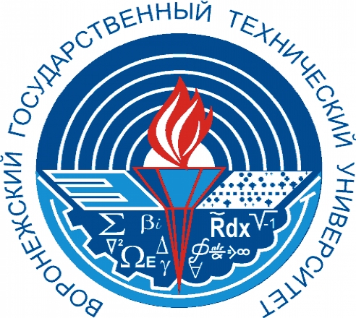

VII
INTERNATIONAL SCIENTIFIC AND PRACTICAL CONFERENCE

«COMPLEX PROBLEMS OF TECHNOSPHERE SECURITY»

24-25 february 2022

VORONEZH

CONDITIONS FOR PARTICIPATION IN THE CONFERENCE

Dear colleagues! We invite You to take part in
International scientific and practical conference«Complex problems of technosphere security»

February 24-25, 2022
Voronezh State Technical University
The Organizing Committee of the conference asks you
to send applications, presentations
until February 23, 2022
articles until March 31, 2022

February24-25 2022 Voronezh state technical University the conference organizing Committee asks You to send applications and presentations by February 23 2022, and articles by 31 March 2022. On Your request and article will program the VI-thinternational conference and prepared conference materials and registration of articles in the bibliographic database RSCI. Conference materials are indexed by ISSN: 2618-9739 of the Russian Federation.
The organizing Committee reserves the right not to include articles that do not correspond to the scientific direction of the conference.

Plagiarism check is carried out by RIO Voronezh state technical University!

OFFICIAL LANGUAGES OF THE CONFERENCE
Russian and English.

Organizing Committee of the conference
Executive Secretary of the Conference
Zvyagintseva Alla Vitalievna
Mobile phone. +7 950-750-10-62
E-mail: zvygincevaav@mail.ru

The requirements for the design of materials for publication and the application form for participation in the conference are presented in the files attached to this letter:
1. Information about the main directions of the conference and the application form for participation (Appendix № 1).
2. Sample design of the article (Appendix № 2).
3. Sample design of the presentation (Appendix №3).

You can receive the materials of the I-VI International Scientific and Practical Conferences «Complex problems of technosphere security» for 2014-2021 by e-mail, by sending an application to our address or on the website (archive):
WEBSITE: http://www.б-б.su

Conducting remote - online. Participation is free, provided a brief presentation of your article is published on the conference website. Articles will be published in the materials only after passing plagiarism!
For any questions, please contact this email address, phone number or website.

ORGANIZING COMMITTEE OF THE CONFERENCE

Drozdov Igor Gennadievich - Doctor of Technical Sciences, Professor, First Vice-Rector, Vice-Rector for Science of VSTU (Voronezh, Russia).
Vladimir Arkadyevich Devisilov - Candidate of Technical Sciences, Associate Professor of Bauman Moscow State Technical University, Chairman of the Federal UMO «Technosphere Safety and Environmental Management», Editor-in-chief of the journal "Safety in the Technosphere" (Moscow, Russia).
Valery A. Nebolsin - Doctor of Technical Sciences, Professor, Dean of the Faculty of Radio Engineering and Electronics of VSTU (Voronezh, Russia).
Tertyshnikov Alexander Vasilyevich - Doctor of Technical Sciences, Head of Science. sotr.,FSBI«Institute of Applied Geophysics named after Academician E.K. Fedorova» (Moscow, Russia).
Ryazhskikh Viktor Ivanovich - Doctor of Technical Sciences, Professor, Head of the Department of Applied Mathematics and Mechanics, Dean of the Faculty of Mechanical Engineering and Aerospace Engineering of VSTU (Voronezh, Russia).
Mozgovoy Nikolay Vasilyevich - Doctor of Technical Sciences, Professor, Department of «Technosphere and Fire Safety» VSTU (Voronezh, Russia).
Rusinov Pavel Sergeevich - Doctor of Geographical Sciences, Professor, Academician of the Russian Academy of Sciences, Department of Life Safety of VSPU (Voronezh, Russia).
Asminin Viktor Fedorovich - Doctor of Technical Sciences, Professor, Head of the Department. «Life Safety and Legal Relations» at the G.F. Morozov State Technical University (Voronezh, Russia).
Isachenko Alexander Petrovich - Associate Professor of the Department of Land Management of the State University of Land Management, Academician of the Russian Academy of Sciences, Honorary Doctor of the Institute of Agroecology and Environmental Management of the National Academy of Agrarian Sciences (NAAS) of Ukraine, coordinator of international training programs of GUZ with universities of neighboring countries (Moscow, Russia).
Zhuravlev Dmitry Vladimirovich - Candidate of Technical Sciences, Associate Professor, Head of the Department of Radioelectronic Devices and Systems, Deputy Dean of FRTEVSTU (Voronezh, Russia).
Skripachev Vladimir Olegovich - Candidate of Technical Sciences, Assoc. Russian Technological University (RTU MIREA), Moscow.
Zvyagintseva Alla Vitalievna - Candidate of Technical Sciences, Associate Professor of the Department of Chemistry and Chemical Technology of Materials at VSTU, Executive Secretary (Voronezh, Russia).
Sazonova Svetlana Anatolyevna - Candidate of Technical Sciences, Associate Professor of the Department of Technosphere and Fire Safety of VSTU (Voronezh, Russia).
Rastorguev Igor Polikarpovich - Candidate of Geological Sciences, Associate Professor of the Department of Hydrometeorological Support Military Training and Research Center «Air Force Academy named after Professor N.E. Zhukovsky and Yu.A. Gagarin» (Voronezh, Russia).

SCIENTIFIC COMMITTEE OF THE CONFERENCE

Severtsev Nikolay Alekseevich - Honored Worker of Science and Technology of the Russian Federation, laureate of the State Prize. USSR Prizes, laureate of the Government of the Russian Federation in the field of science and education, Doctor of Technical Sciences, Professor, Academician of the Academy named after K.E. Tsiolkovsky, Vice Admiral in / o, Head. Department of Nonlinear Analysis and Security Problems of the A.A. Dorodnitsyn Computing Center, RAS (Moscow, Russia).
Ivanov Nikolay Igorevich - Doctor of Technical Sciences, Professor, Head of the Department «Ecology and Life Safety» of D.F. Ustinov BSTU «Voronezh», Honored Scientist of the Russian Federation (St. Petersburg, Russia)
Gerald G. Manshin - Corresponding Member of the NASB, Academician of the IIT iBIA, Doctor of Technical Sciences, Professor, Laureate of the USSR State Prize (GNU «VoronezhUnited Institute of Mechanical Engineering of the NAS of Belarus» (Minsk, Republic of Belarus).
Lutovac Mitar - Academician, Professor, Doctor (Union Nikola Tesla University, Belgrade, Serbia and Faculty of Management, Herceg Novi, Montenegro).
Luzzi Sergio is a professor at the University of Florence (Florence, Italy). Visiting lecturer at the School of Architecture at the Royal College of Art (London, England).
Eleonora Carletti is Director of the Institute of Agricultural and Earthmoving Machines (IMAMOTER-CNR) and Head of the IMAMOTER Research Group (Ferrara, Italy).
Ressner Frank - Professor, Head of the Department of Technical Chemistry of the Oldenburg State University. Karl von Osetsky (Germany).
Mirjanic Dragolyub is an academician of the Academy of Sciences of the Serbian Republic (Banja Luka, Republika Srpska).
Saechnikov Vladimir Alekseevich - Doctor of Physical and Mathematical Sciences, Professor, Head of the Department of Physics and Aerospace Technologies of the Faculty of Radiophysics and Computer Technologies of BSU (Minsk, Republic of Belarus).
Kugeyko Mikhail Mikhailovich - Doctor of Physical and Mathematical Sciences, Professor of the Department of Quantum Radiophysics of Optoelectronics of BSU (Minsk, Republic of Belarus).
Abdullaev Sabur Fuzailovich - Doctor of Physical and Mathematical Sciences, Professor, Laboratory of Atmospheric Physics of the S.U.Umarov Institute of Physics and Technology of the National Academy of Sciences of Tajikistan)Dushanbe, Republic of Tajikistan).
Yulia Arkadyevna Omelchuk - Candidate of Chemical Sciences, Associate Professor, Director of the Institute of Nuclear Energy and Industry, SevSU (Sevastopol, Russia).
Trofimov Viktor Titovich - Dr. geol.-Miner. of Sciences, Professor, Academician of the Russian Academy of Sciences and MANSH, Head of the Department of Engineering and Environmental Geology of the Geological Faculty of Lomonosov Moscow State University (Moscow, Russia).
Vasiliev Andrey Vitalievich - Doctor of Technical Sciences, Professor, Head of the Department «Chemical Technology and Industrial Ecology» of SSTU, Honorary Worker of Higher Professional Education of the Russian Federation (Samara, Russia).
Gusev Alexander Leonidovich - Editor-in-chief of the International Scientific Journal «Alternative Energy and Ecology» (ISJAEE) (Sarov, Russia).
Us Nikolay Alexandrovich - Doctor of Technical Sciences, Professor, member of the Academy of Informatization of Education, VUNTS VVS «VVA» named after prof. Zhukovsky and Gagarin (Voronezh, Russia).
Khromova Galina Alekseevna - Doctor of Technical Sciences, Professor of the Department «Electric Transport and high-speed electric rolling stock», Tashkent Institute of Railway Transport Engineers named after Akmalaikramov (TASHIIT) (Tashkent, Republic of Uzbekistan).
Pyotr Ignatievich Pigulevsky - Doctor of Geological Sciences, Senior Scientist. sotr. Institute of Geophysics of the National Academy of Sciences of Ukraine (Dnipro, Ukraine).
Mikhailov Alexander Nikolaevich - Doctor of Technical Sciences, Professor, Head of the Department of «Technology of Mechanical Engineering» DonNTU (Donetsk, Donetsk People's Republic).
Zapletnikov Igor Nikolaevich - Doctor of Technical Sciences, Professor, Head of the Department of Food Production Equipment of Donetsk National University of Economics and Trade named after M. Tugan-Baranovsky. (Donetsk, Donetsk People's Republic).
Kuznetsov Ilya Evgenievich - Doctor of Technical Sciences, Associate Professor, Head of the Department of Hydrometeorological Support Military Training and Research Center «Air Force Academy named after Professor N.E. Zhukovsky and Yu.A. Gagarin» (Voronezh, Russia).
Oleg Borisovich Rudakov - Doctor of Chemical Sciences, Professor, Head of the Department of Chemistry and Chemical Technology of Materials at VSTU (Voronezh, Russia).
Ishchuk Igor Nikolaevich - Doctor of Technical Sciences, Associate Professor of the beginning. 42 Department of robotic complexes and air-based systems Military Training and Research Center "Air Force «Air Force Academy named after Professor N.E. Zhukovsky and Yu.A. Gagarin» (Voronezh, Russia).
Semen Kurolap - Doctor of Geological Sciences, Professor, Head of the Department of Geoecology and Environmental Monitoring, Dean of the Faculty of Geography, Geoecology and Tourism of the VSU (Voronezh, Russia).
Kosinova Irina Ivanovna - Dr. geol.-Miner. sciences, Professor, Head of the Department of «Ecological Geology» of VSU; Academician of MANEB (Voronezh, Russia).
Pashyan Ararat Alexandrovich - Doctor of Chemical Sciences, Professor, Academician of MANEB, Head of the Department of Chemistry of the Bryansk State Academy of Engineering and Technology (Bryansk, Russia).
Chukarin Alexander Nikolaevich - Doctor of Technical Sciences, Professor, Academician of the MAEB, Head of the Department «Fundamentals of Machine Design», Honorary Worker of the Higher Educational Institution of the Russian Federation, RSUPS (Rostov-on-Don, Russia).
Lukina Lidiya Ivanovna - Candidate of Chemical Sciences, Associate Professor of the Department of Radioecology and Environmental Safety of SevSU, Institute of Nuclear Energy and Industry (Sevastopol, Russia).
Reliable Lyudmila Ivanovna - Candidate of Geol.-miner. of sciences, associate professor, head of the lab. «Deep structure, geodynamics of seismic monitoring» named after prof. A.P. Tarkov, VSU (Voronezh, Russia).

SECRETARIAT:
Zvyagintseva Alla Vitalievna - Candidate of Technical Sciences, Associate Professor of the Department of Chemistry and Chemical Technology of Materials of BSTU, Executive Secretary (Voronezh, Russia).
Maslikova Tatiana Ilyinichna - Candidate of Physical and Mathematical Sciences, Associate Professor of the Voronezh Institute of Economics and Social Management (Voronezh, Russia).
Natalia A. Kryukova - Candidate of Geographical Sciences, Associate Professor of the Department of «Ground Systems of Aerial Reconnaissance Complexes» Military Training and Research Center «Air Force "Air Force Academy named after Professor N.E. Zhukovsky and Yu.A. Gagarin» (Voronezh, Russia).
Kulneva Violetta Vladimirovna is an engineer at VSTU (Voronezh, Russia).
Appendix № 1

THE MAIN DIRECTIONS OF THE CONFERENCE

1. Basic, special and information technologies for security. Analysis, assessment and technologies for reducing natural, man-made and fire risk.
2. Aerospace, radio-electronic, hydrometeorological and other safety technologies. Systems for monitoring and forecasting the state of the atmosphere, hydrosphere and lithosphere.
3. Industrial ecology and chemistry, wastewater treatment and gas emissions. Low-waste and non-waste production technologies. Control, diagnostics of the quality and safety of materials in construction, industry, and energy.
4. Safety issues in the application of physical fields, special materials and nanotechnology. Renewable and alternative energy sources.Acoustics.
5. Economic-legal, social, philosophical, medical-psychological and biological aspects of technosphere security.Labor protection
6. Energy, fire, environmental, chemical, physical and information security of the technosphere.

Application for participation in the VII International Scientific and Practical Conference "Complex problems of technosphere security"
23 February 2022 Voronezh

Full name of the author
(in full)

A country

City

Place of work (study)

Academic degree, title, position

Age up to 35 years or older

Title of the article

Section name

If the article will be prepared based on the results of the project supported by the RFBR, then specify the project number

e-mail
Telephone

*If there are several authors, then information about them is filled in in one file and for each in a separate table.

In order to draw up the conference work program and form a collection of papers, we ask you to send applications, articles and presentations to our address, remote - online.

Appendix № 2

THE DESIGN OF THE ARTICLE

To participate in the conference,
you must send an email to
zvygincevaav@mail.ru
applications, articles, presentations:

1. Application for participation in the conference (according to the attached Appendix 1) and presentation (Appendix № 3) by February 23, 2022.
2. An article of 4 to 10 (full) pages in 1 copy, designed according to the established requirements. The list of references is not less than 5 sources and not more than 20 (Appendix 2). The deadline for submitting articles is March 31, 2022.
3. The materials of the articles are published in the author's editorial office, therefore, we draw the attention of the authors of the articles to compliance with the rules of registration of materials.
4. Materials are provided in electronic form marked "for the conference" and should be named by the surname of the first author.
5. The organizers of the conference will definitely confirm receipt of your work. If there is no response, it is necessary to send the materials again to the email address marked "to the conference".
5. Publication of a collection of articles on the submitted materials in 2022.
6. Check for plagiarism.

DESIGN REQUIREMENTS

1. Place the materials on a sheet of formatom4 (210x297) with margins: top - 2.5 cm; bottom - 2 cm; left - 2 cm; right - 2 cm.. The pages should be numbered at the bottom of the sheet, in the middle. The materials should be designed using the WinWord editor (versions 2003-2007), in the volume from 4 to 15 (full) pages in TimesNewRoman font size 12. Interval – 1. Paragraph indentation - 1, 25. Text alignment in width with automatic hyphenation.
2. The order of registration. The materials must meet the structural scheme: UDC, initials of the authors' surnames, abstract and keywords, main text, conclusions, references, name of the organization in Russian. Then the surname, first name, patronymic of the authors, the title of the article, abstract, keywords and the name of the organization in English.
3.Print the name in capital letters, without hyphenation, center. After 1 empty line, in lowercase letters - the surnames and initials of the authors. After 1 empty line - abstract and keywords in Russian (5-10 lines after 1 interval, MSTimesNewRoman, 9 in font). Next - the main text (the language of presentation - at the choice of the authors). Next, the name of the organization (MSTimesNewRoman, 9 in font, centered). After 1 empty line – the names of the authors, title, abstract, keywords, the name of the organization in English (5-10 lines after 1 interval, MSTimesNewRoman 9 font).
4. Drawings, illustrations, diagrams and diagrams should be made in the format *jpg, *gif, *tif, *bmp, * pcx, *dwg, with dimensions of at least 60×60 mm, embedded objects and placed in the course of materials. Tables should have a name. In the embedded object, their number and name are indicated under each drawing or above the table. Each drawing or table should have one interval at the top and bottom of the text.
5. Formulas should be centered and numbered (if there are references to them in the text). The numbers are indicated in parentheses and aligned along the right border of the fields.
Formulas must be executed in the MicrosoftEquation editor: Full - 12 pt, Subscript/Superscript - 10 pt, Sub-Subscript/Superscript - 8 pt, Symbol - 12 pt, Sub-Symbol - 10 pt.
6. The literature should be designed in accordance with the sample design of the bibliographic list (GOST 7.1 - 2003), given in the appendix «Design of literature».
The number of references to literature is not less than 5 and not more than 20 in the article.
7. Files should not contain viruses.
8. Materials with significant deviations from the requirements and topics of the conference, as well as those received by the organizing committee late and not plagiarized, will not be published.

EXAMPLE OF ARTICLE DESIGN

UDC 628.4; 504.06

V.F. Babkin¹, M. Lutovats²

USE OF SUBSTRATA OF TREATMENT FACILITIESOF MEAT-PROCESSING PLANTS

The technology, which provides sewage treatment of the meat-processing enterprises, is shown, thus using substrata of treatment facilities for production of synthetic fuel.
Key words: fuza, kanyga, proteinaceous and fatty weight, electro floatation technologies of sewage treatment, ejection, energy consumption

The development of animal husbandry, poultry farming with a territorial concentration of production inevitably leads to an aggravation of environmental problems associated with wastewater treatment [1].

F = D + C, (1)

whereD – the parameter characterizing C - the value....
Explanations to fig. 1.

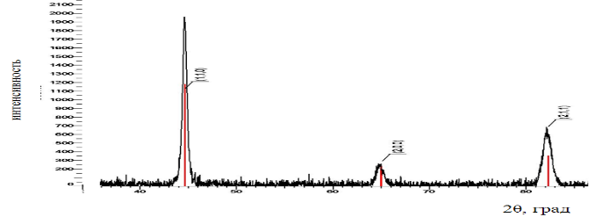

Fig. 1. The name of the picture

Explanations to Table 1.
Table 1
Table 1 Names

1 | 2 | 3 | 4 | 5
text | text | text | text | text

Literature

1. Hamburg, V.Yu. Hydrogen. Properties, receipt, storage, transportation, application: Reference ed. /D.Y. Hamburg, V.P. Semenov, N.F. Dubovkin, L.N. Smirnov; edited by D.Y. Hamburg, N.F. Dubovkin. - M.: Chemistry, 1989. - 672 p.

¹Federal State Budgetary Educational Institution of Higher Education «Voronezh State Technical University»
²Serbian Royal Academies of Sciences, Belgrade, Serbia

В.Ф. Бабкин¹, М. Лутовац²

ИСПОЛЬЗОВАНИЕ СУБСТРАТОВ ОЧИСТНЫХ СООРУЖЕНИЙ МЯСОКОМБИНАТОВ

Продемонстрирована технология, которая обеспечивает очистку сточных вод мясоперерабатывающих предприятий, при этом используя субстраты очистных сооружений для производства синтетического топлива
Ключевые слова: фуза, каныга, белково-жировая масса, электрофлотационные технологии очистки сточных вод, эжекция, энергетические затраты

¹ФГБОУ ВО «Воронежский государственный технический университет»
²Сербская королевская академия наук,
г. Белград, Сербия
Appendix № 3

PRESENTATION DESIGN

The best presentations of the reports will be awarded with diplomas, and participation will be marked with a certificate at the request of the authors. A form of participation with an online presentation is provided (remote E-presentation – from 5 to 15 slides in Russian and/or English - are issued in free form in pdf/ppt format).
The presentation language is chosen by the participants (Russian or English).

EXAMPLE OF PRESENTATION DESIGN

1 slide.
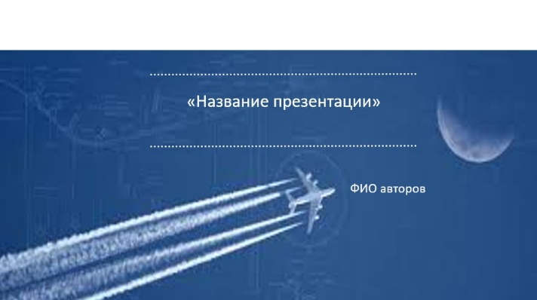

2 slide.
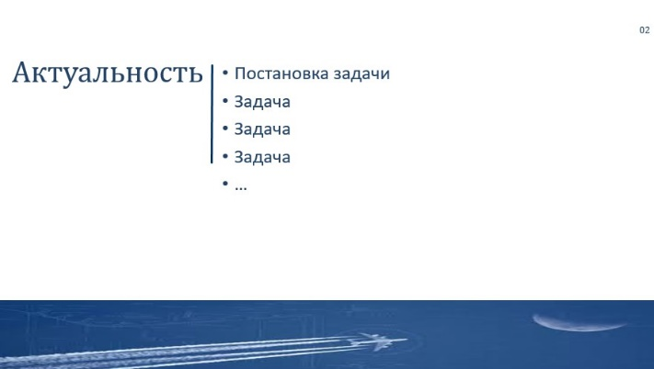

3slide.
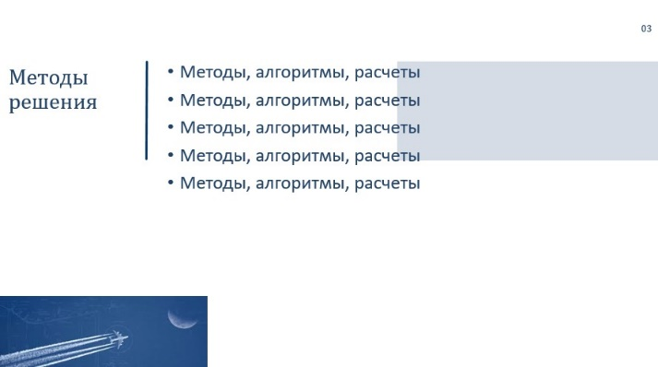

4 slide.
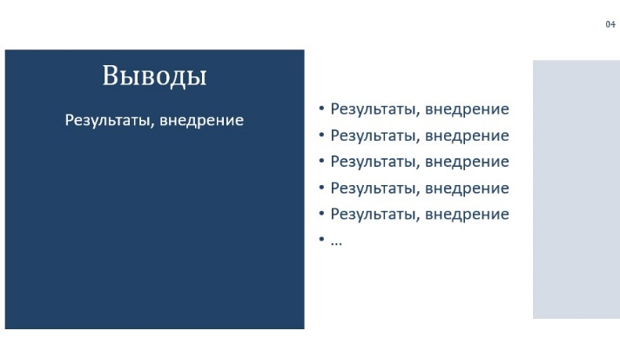

5 slide.
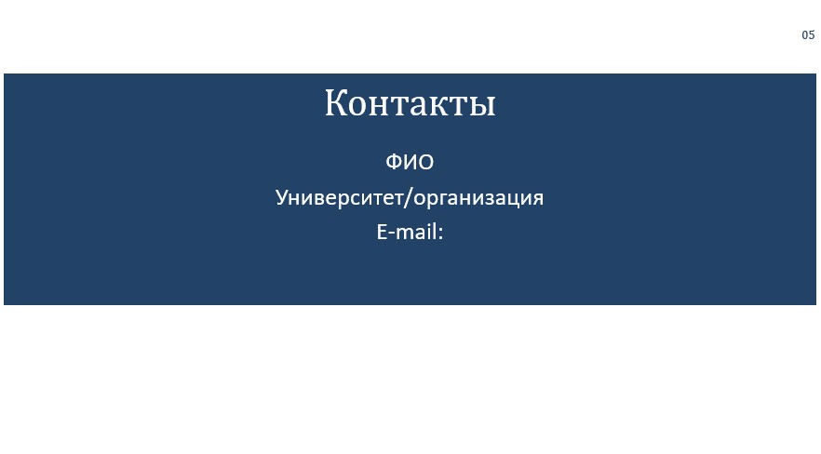

*It is allowed to make a presentation without using the recommended template in pdf/ppt.

